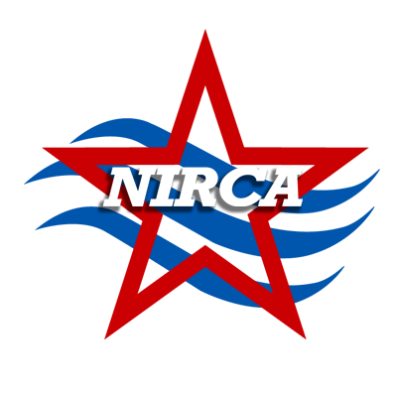
National Intercollegiate Running Club Association

Championships Eligibility Form

The minimum eligibility requirement for undergraduate students is full-time enrollment, and for graduate students a minimum of
six (6) credit hours, at the institution for which they represent, throughout the semester/quarter of the championships.
Please submit one form for your Men’s team and a separate form for your Women’s team.
School: _________________________ ☐ M ☐ F
Season: ☐ Spring ☐ Fall Year: _________
Event Date: _____/_____/_____

 |  | Currently Enrolled? | Undergrad or Grad Student? | Current Credit Load? | In Good Academic Standing? | Final Semester Student? | Permission to Release Academic Info
Student Name | Student ID # | (Y/N) | (U/G) | (#) | (Y/N) | (Y/N) | Signature
Registrar: Please verify the above information and draw a red line after the last name you verified. By doing so, it certifies that the above listed student-athletes are currently enrolled for the credit hours stated, have above a 2.0 cumulative GPA and have paid the appropriate student fees.
NOTE - College/University seal of certification must be placed on this form to validate all of the above information.
Mail completed forms to:
NIRCA - Eligibility
11807 Allisonville Rd. #519, Fishers, IN 46038
Mail 7 days before event date.
List your school’s requirement for Full Time Undergraduate Enrollment = ______credit hours

X_______________________________________ ____________________ _________________
Institution’s Registrar or Rec Sports Director Phone Number Date

